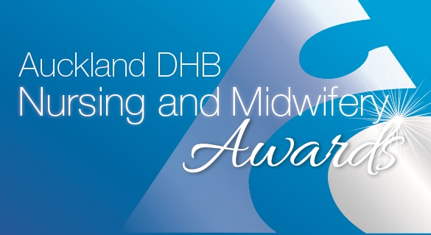
Primary Health Care Nursing Award
NOMINATION FORM

Sponsored by Auckland Health Foundation
- Please complete ALL sections of the nomination form.
- Nomination forms must be submitted on or before 4 March 2019

NOMINEE DETAILS (The person who are nominating’s details)
Full Name:
Current role:
Service area:
Email address:
NOMINATOR DETAILS (Your details)
Full name:
Service area:
Contact phone number:

Please tell us why you are nominating this person.
Please tell us why you are nominating this nurse or midwife, include something in each of the appropriate sections. Give specific examples, this will strengthen the nomination and help the judges select the finalists and winners.
Summarise why you are nominating this person, this will be used in the booklet on the evening (150 words maximum).
Please provide details of why you are nominating this person, addressing the criteria below (provide specific examples):
- Acknowledged by peers, the primary care team and patients as an excellent nurse.
- Takes the lead in new initiatives and quality improvement activities to achieve equitable outcomes and best practice.
- Works in partnership with the patient and their whānau to form working relationships with all disciplines to get the support they need to improve their health and independence.
- Works with other providers to improve integration across the whole patient journey.
- Raises the profile and voice of primary health care nursing.

(800 words maximum)

To submit a nomination form, please make sure you have read the criteria and entry rules. You can find these on Hippo
Once you have completed your application form please email it to NurseMidwifeAwards@adhb.govt.nz.
Thank you for taking time to submit your nomination.

