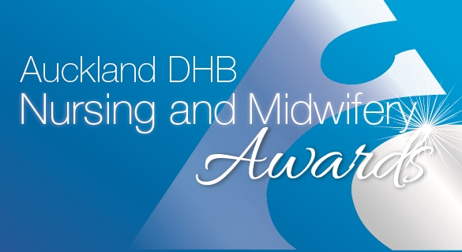
Pacific Nursing and Midwifery Award
NOMINATION FORM

Sponsored by Auckland Health Foundation
- Please complete ALL sections of the nomination form.
- Nomination forms must be submitted on or before 4 March 2019

NOMINEE DETAILS (The person who are nominating’s details)
Full Name:
Current role:
Service area:
Email address:
NOMINATOR DETAILS (Your details)
Full name:
Service area:
Contact phone number:

Please tell us why you are nominating this person.
Please tell us why you are nominating this nurse, include something in each of the appropriate sections. Give specific examples, this will strengthen the nomination and help the judges select the finalists and winners.
Summarise why you are nominating this person, this will be used in the booklet on the evening (150 words maximum).
Please provide details of why you are nominating this person, addressing the criteria below (please provide specific examples to help the judges with their decision-making):

- Demonstrate engagement with Pacific communities and actions that influence positive Pacific health outcomes.
- Demonstrate and embrace the Auckland DHB and Pacific values and how this impacts on their care and service provision.
- Role model good leadership qualities, this can include mentorship, clinical supervision, and supporting other Pacific nurses.
- Demonstrate collaborative working relations with the wider health and social sector to improve the health and wellbeing of Pacific people and communities.
- Promote and support the interests of the wider Pacific nursing community

(800 words maximum)

To submit a nomination form, please make sure you have read the criteria and entry rules. You can find these on Hippo
Once you have completed your application form please email it to NurseMidwifeAwards@adhb.govt.nz.
Thank you for taking time to submit your nomination.

