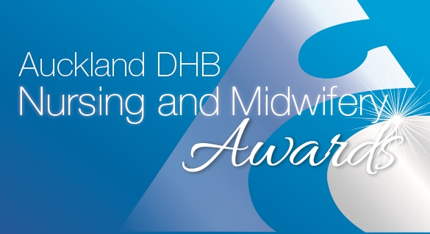
Te Kauae Raro Māori Nursing and Midwifery Award
NOMINATION FORM
Sponsored by Auckland Health Foundation
- Please complete ALL sections of the nomination form.
- Nomination forms must be submitted on or before 4 March 2019

NOMINEE DETAILS (The person who are nominating’s details)
Full Name:
Current role:
Service area:
Email address:
NOMINATOR DETAILS (Your details)
Full name:
Service area:
Contact phone number:

Please tell us why you are nominating this person.
Please tell us why you are nominating this nurse or midwife, include something in each of the appropriate sections. Give specific examples, this will strengthen the nomination and help the judges select the finalists and winners.
Summarise why you are nominating this person, this will be used in the booklet on the evening (150 words maximum).
Please provide details of why you are nominating this person, addressing the criteria below (please provide specific examples to help the judges with their decision-making):

- Angamua- demonstrates leadership skills or actions which positively influence health and wellbeing outcomes for Māori.
- Haere Mai- demonstrates the ability to connect with others and establish effective working relationships with colleagues and caring relationships with whānau, hapu, iwi, urban Māori
- Manaaki- is a role model to others by being respectful and caring. Has the ability to empower and care for others through education, mentorship and engagement or research the influences of positive health and wellbeing of Māori.
- Tūhono- demonstrates the ability to encourage and achieve unity and establish collaborative working relationships to improve health and wellbeing outcomes of Maori.

(800 words maximum)

To submit a nomination form, please make sure you have read the criteria and entry rules. You can find these on Hippo
Once you have completed your application form please email it to NurseMidwifeAwards@adhb.govt.nz.
Thank you for taking time to submit your nomination.

