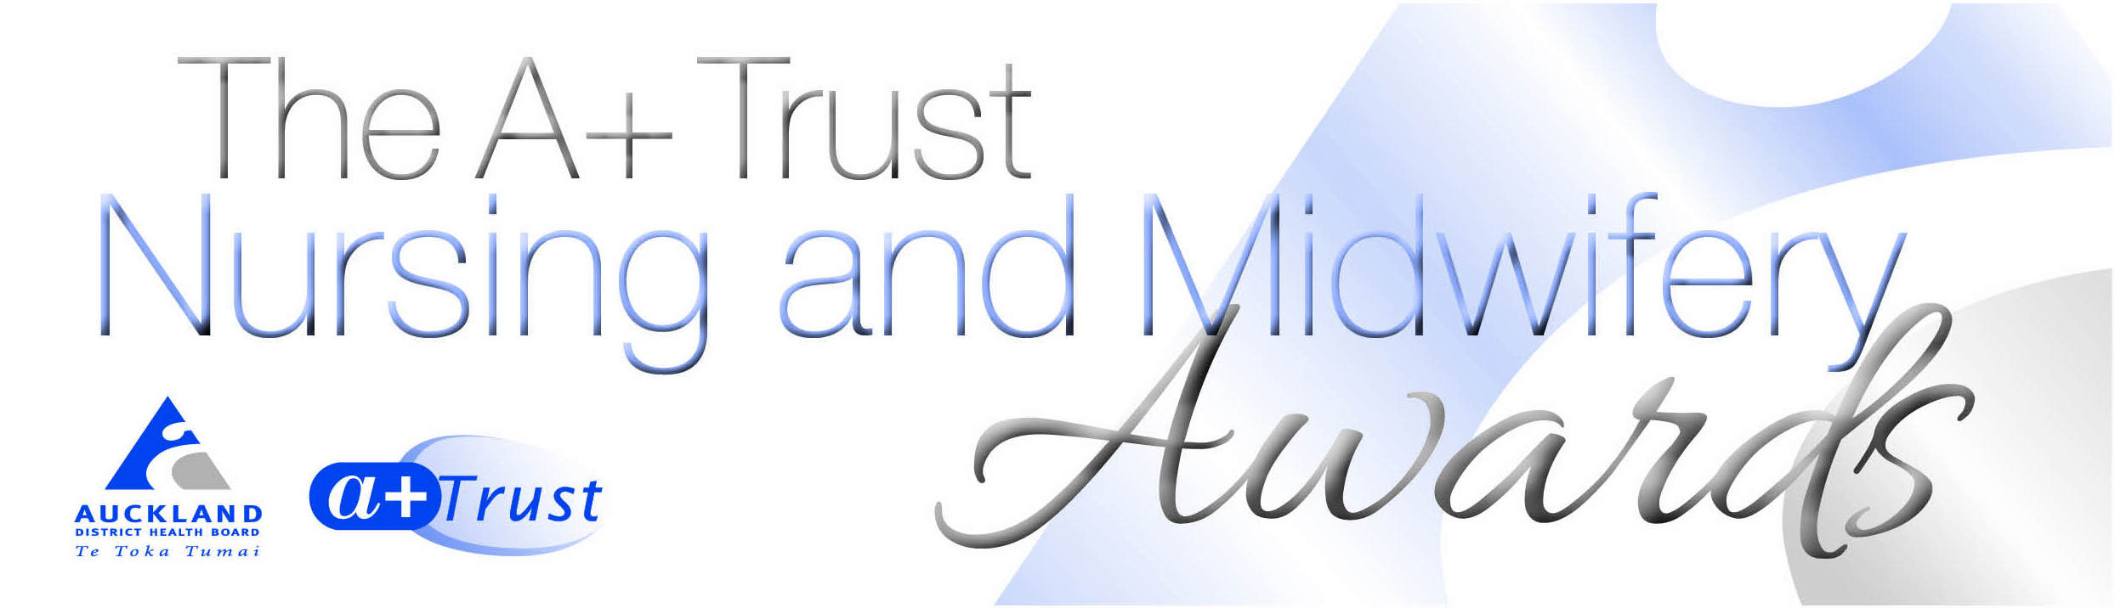

Nomination form:
Primary Health Care Nursing Award

- Please complete ALL sections of the nomination form.

- Nomination forms must be submitted on or before 27 March 2017

- Completed nominations should be emailed to NurseMidwifeAwards@adhb.govt.nz

About the person you are nominating:
Full name:
Current role:
Primary Care provider
Email address:
About you:
Full name:
Service area:
Contact phone number/email address:

Tell us why you are nominating this nurse, please include something in each of the appropriate sections.

Acknowledged by peers, the primary care team and patients as an excellent nurse
Takes the lead in new initiative and quality improvement to achieve equitable outcomes and best practice.
Works in partnership with the patient and their family to form who working relationship to get the support they need to improve their health and independence.
Works with other providers to improve integration across the whole patient journey
Raises the profile and voice of primary care health nursing

